Data Analysis of Climate Change

7PAM2000 Applied Data Science-1
Assignment-2

Name: Anusha VishuMolakala
Student Id: 22033054

line 1: 1st Given Name Surname
line 2: dept. name of organization
(of Affiliation)
line 3: name of organization
(of Affiliation)
line 4: City, Country
line 5: email address or ORCID

line 1: 2nd Given Name Surname
line 2: dept. name of organization
(of Affiliation)
line 3: name of organization
(of Affiliation)
line 4: City, Country
line 5: email address or ORCID

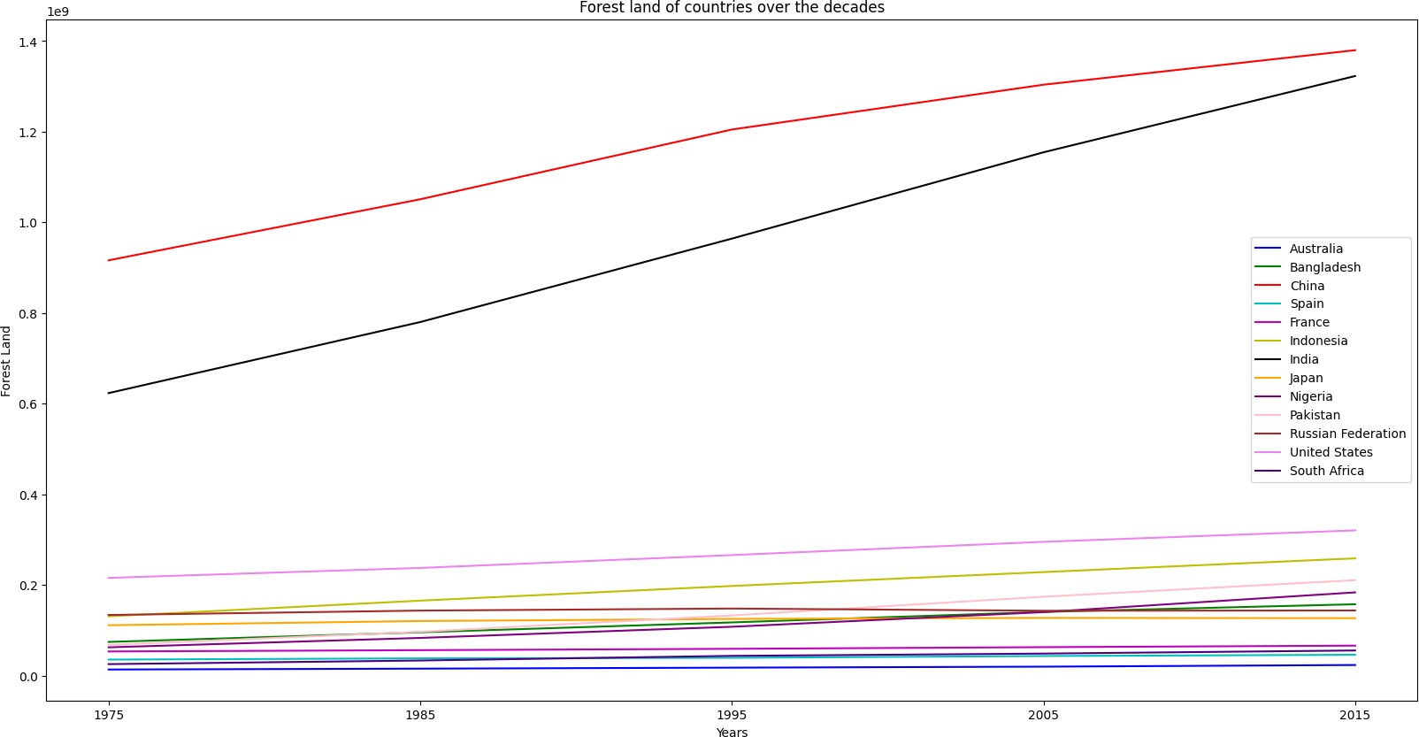
Abstract— In this analysis, we explored the relationship between climate change and several variables in six countries across different continents, including energy use, CO2 intensity, and agricultural land area. Specifically, we focused on two countries, Bangladesh and India. We will now delve into the data and create visualizations to better understand these attributes.

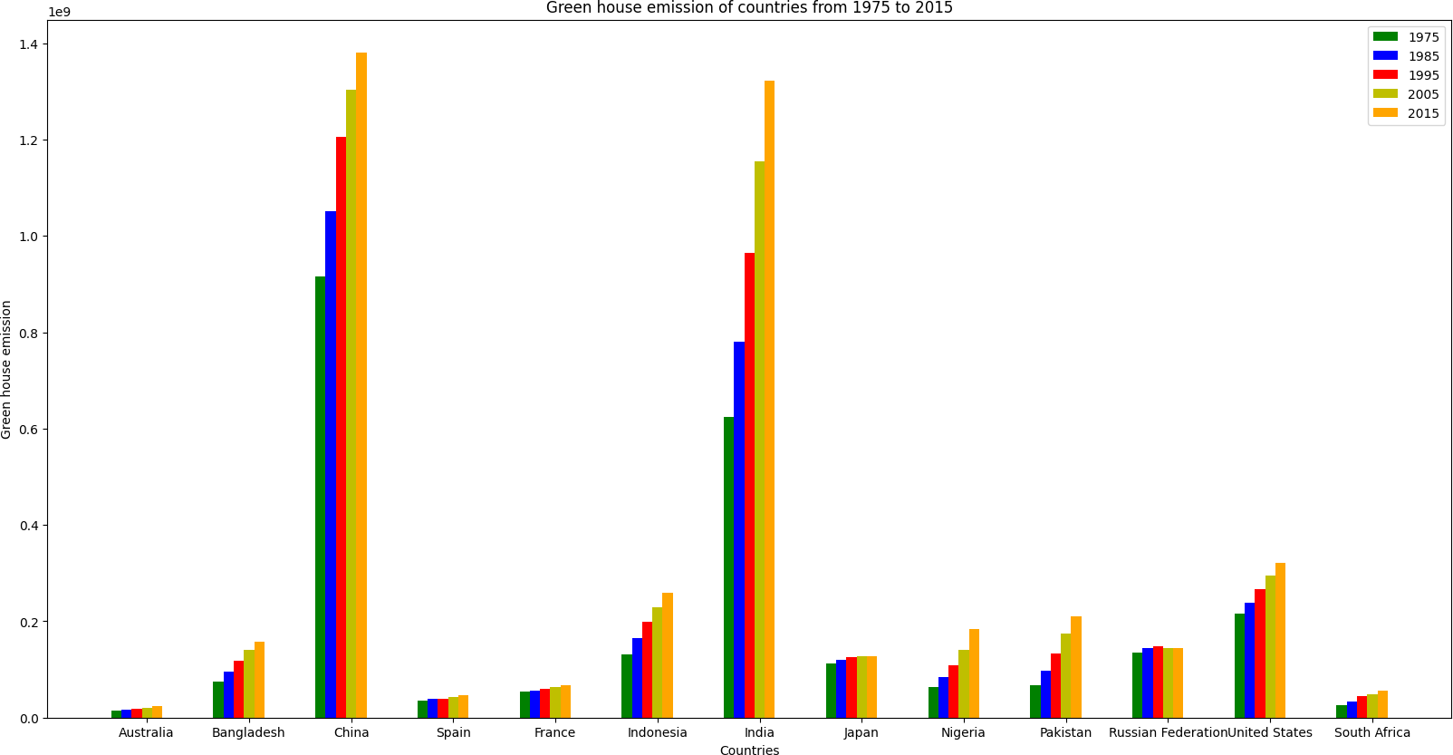
Figure 1
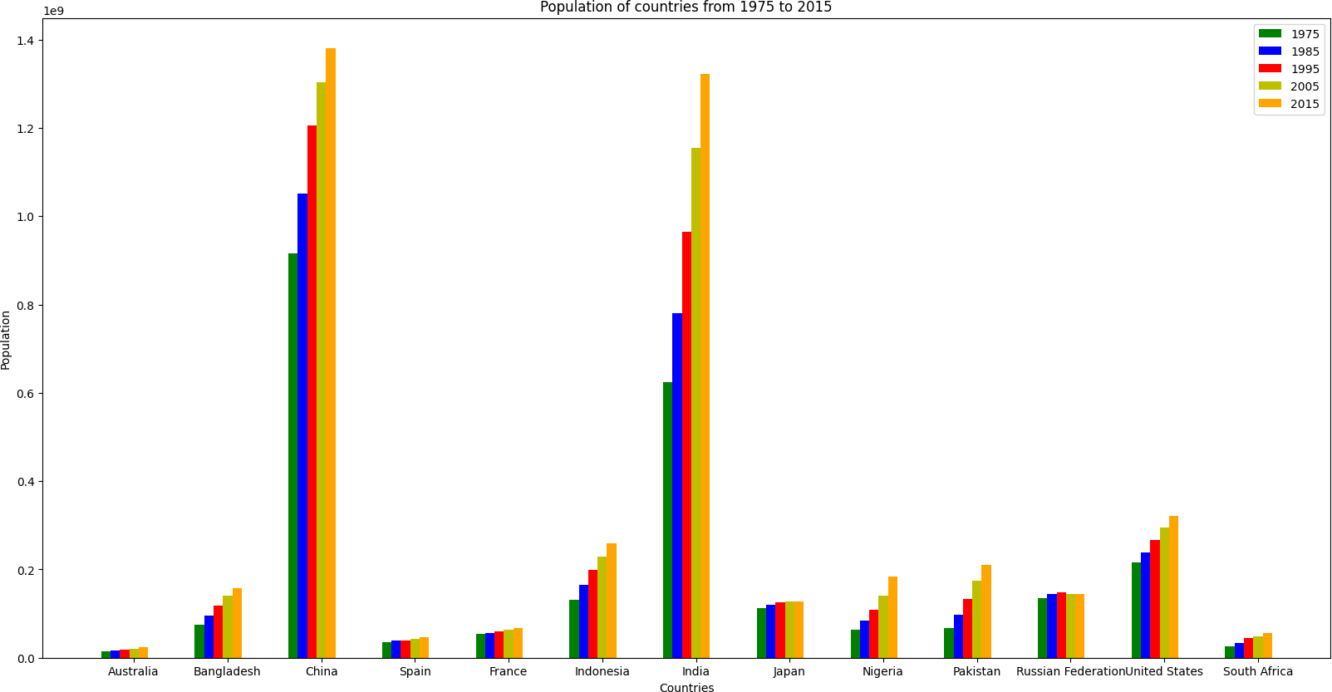
Figure 1 describes about Green house emission has been tremendously increasing in both China and India as population of both the countries is high and usage of vehicles is also more over the decades in both the countries. Next populated country is United States and emission of green house is also been increasing over the decades.
Figure 2
Figure 2 describes about As China and India has more rivers and more areable land which is the reason for increase in population as compared to other countries. Also these two are never effected with natural and human calamities which results in population sustainity.
Figure 3
Figure 3 describes about As Area of land is more, the wild life habitant is highly concentrated in China and India over the decades and most unused land has been converted for wild life.
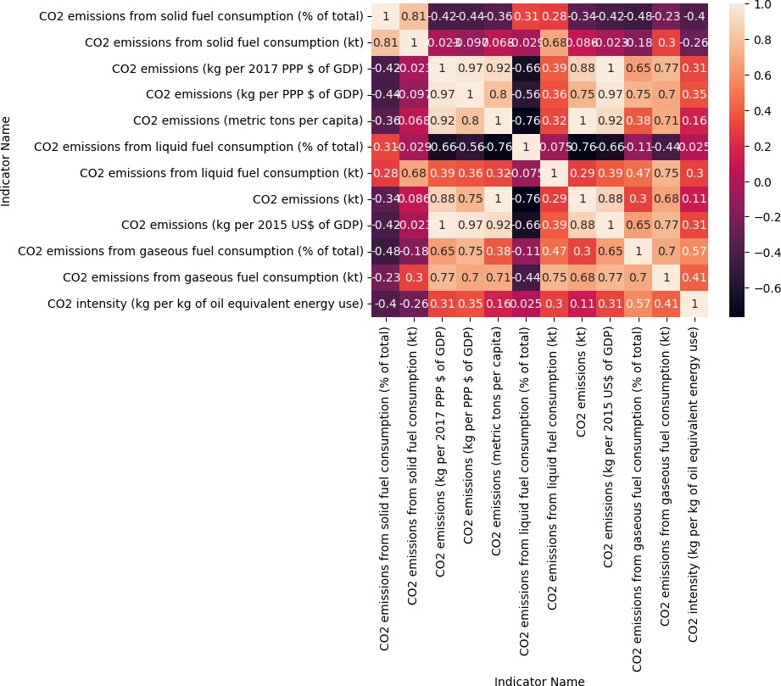
Figure 4
Figure 4 describes about Bangladesh is located at south Asia and resultant areas for more emission of CO2 are: 1.Solid fuel Consumption 2.Gaseous fuel consumption 3.Liquid fuel consumption 4.Intensity of oil equivalent energy usage.

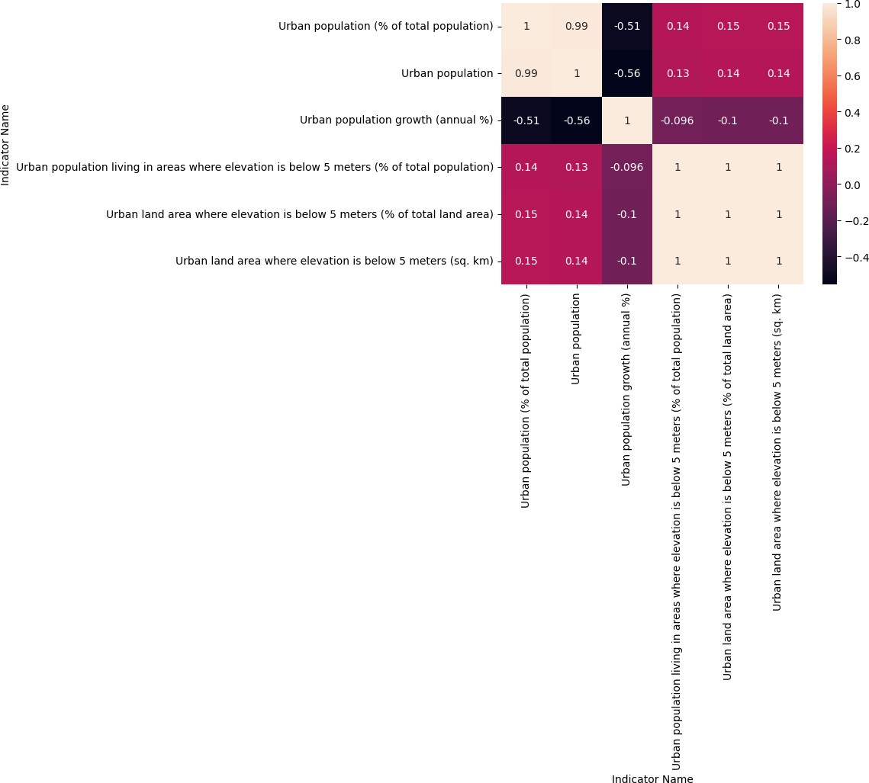

Figure 5
Figure 5 describes about As India is a densily populated country the reasons for increasing urban population are: 1.Devel- opment is also happening as equal to rural areas. 2.People are tend to live comfortably compared to rural areas as opportunties are increasing.

